Lab Report: Calibration and Characterization of an NTC Thermistor
Course Code & Name:PH 3039 - Data Acquisition Laboratory
Student Name: H.G. Kenura R.Gunarathna
Student ID: s17239
Lab Partner(s): Teshan, Kaveesha

Abstract

In this experiment, we calibrated an NTC thermistor using a DS18B20 digital thermometer (±0.5 °C) as the reference, in a stirred water bath from 0 to 98 °C. The NTC was read with a 3.3 kΩ voltage divider and a 10-bit Arduino ADC. We collected one heating and two cooling runs (5321 samples) and fitted a cubic polynomial and the physical NTC β-model. The cubic gives an RMSE of 0.54 °C with a ±1.06 °C 95 % prediction band. The β-model gives β = 3965.3 K and an RMSE of 0.60 °C with only two parameters. The heating/cooling gap (1.15 °C at most) is smaller than the reference error, so we do not claim real hysteresis. The time constant is 3.5 s when heating and 7.7 s when cooling. The combined uncertainty is about ±0.5 °C, mostly from the reference.

1. Introduction & Theoretical Background

The resistance of an NTC falls steeply and not linearly with temperature, and β is different for every part. So the thermistor must be calibrated against a reference. Here the reference is a DS18B20 digital thermometer, which works from −55 to +125 °C and is accurate to ±0.5 °C. The ADC uses V_{cc} as its reference, so supply drift cancels. With the Arrhenius law $R(T)=R_{0}exp[β(1/T-1/T_{0})]$, this gives:
$$r≡R_{NTC}/R_{f}=(1023-ADC)/ADC, lnr=β/T+c, T=1/[Alnr+B]-273.15 (A=1/β)$$
The goals are to calibrate the NTC with a polynomial and with this β-model, check for hysteresis, find the sensitivity and the response time, and estimate the uncertainty.

2. Experimental Setup & Procedure

2.1 Simulations, Apparatus & Materials
The circuit is a simple voltage divider with the NTC connected on one side to GND (Figure 1). A 3.3 kΩ resistor keeps the output within the measurable range. (We tried both configurations and got approximately similar readings.) An Arduino Uno reads the divider midpoint on pin A2 and the DS18B20 on pin 2 about every 1.5 s. Both sensors sit close together in a stirred water bath, cooled with ice and heated with a hot plate.
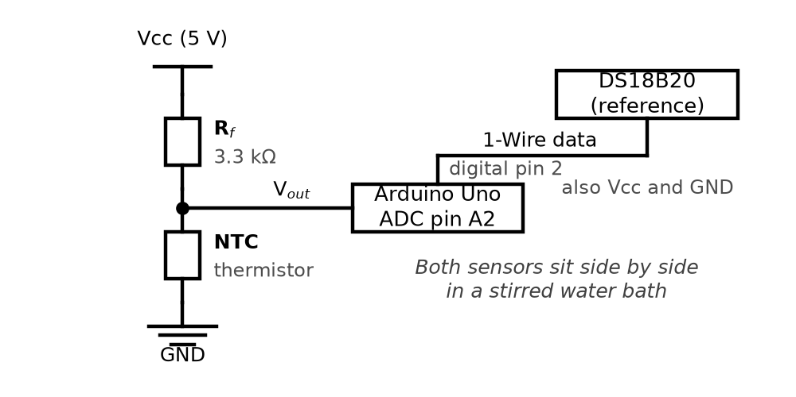
Figure 1. Voltage-divider circuit and reference sensor.

2.2 Experimental Procedure
1. We recorded one heating and two cooling runs between 0 and 98 °C. Other runs had a stuck ADC channel and were not used.
2. We removed empty rows and outliers (beyond 3σ of a first cubic fit; 7 points, all in cooling), then fitted polynomials of degree 1 to 3 and the β-model.
3. For the response time, we moved the NTC again and again between room-temperature water and ice water, and fitted a delayed first-order model to the steps.

3. Results & Data Analysis

3.1 Calibration Data Table
After cleaning, we had 1078 heating and 4243 cooling samples from 0 to 98 °C. The cubic fit is the best (Table 1). The straight line leaves an S-shaped error of up to about 4 °C. The cubic cuts the RMSE to 0.35 °C for heating and 0.55 °C for cooling, and all its terms are significant (|t| > 17). The cooling errors are correlated in time (Durbin–Watson 0.02), so the standard errors are slightly too small.
Table 1. Fit errors in °C for heating (H, N = 1078) and cooling (C, N = 4243).
Degree | R² (H) | RMSE (H) | Max (H) | R² (C) | RMSE (C) | Max (C)
1 | 0.99600 | 2.326 | 3.913 | 0.99265 | 1.462 | 4.010
2 | 0.99718 | 1.951 | 4.146 | 0.99882 | 0.586 | 2.752
3 | 0.99991 | 0.345 | 1.459 | 0.99898 | 0.546 | 1.727

3.2 Model Fitting & Parameter Derivation
We joined the heating and cooling data (N = 5321) and fitted one cubic, where a is the ADC count:
$$T=1.869×{10}^{-7}a^{3}-2.495×{10}^{-4}a^{2}+0.2134a-17.559$$
It has R² = 0.999 and RMSE 0.54 °C. The mean 95 % prediction half-width is ±1.06 °C. For the β-model, a straight line of ln r against 1/T gives β = 3965.3 K, R² = 0.9993 and an RMSE of 0.598 °C, using only two parameters (Figure 2).
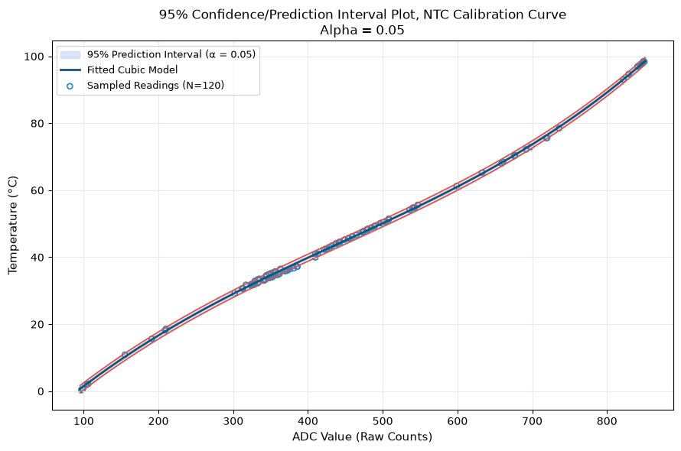 | 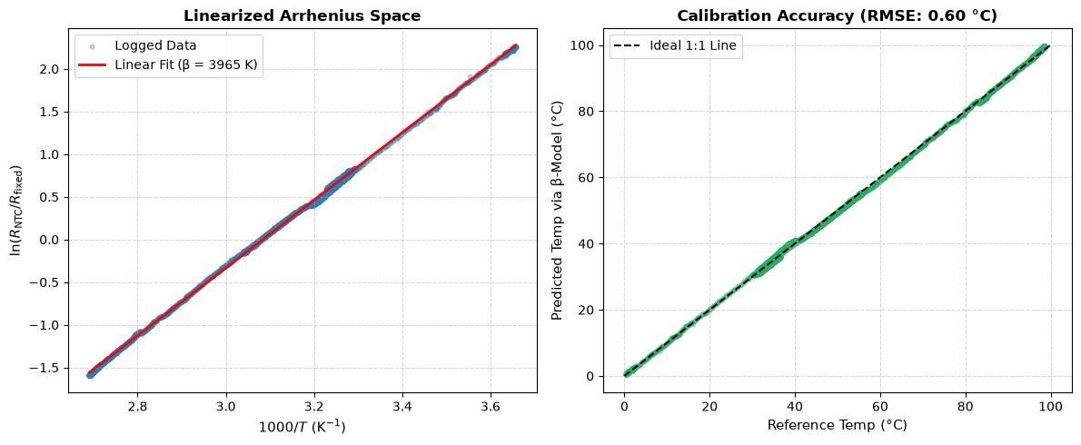
Figure 2. Left: global cubic fit with its 95 % prediction band. Right: Arrhenius fit and β-model accuracy.
We compared the heating and cooling cubics over the shared range (ADC 309–849). The biggest gap is 1.15 °C and the average gap is 0.60 °C. The likely causes are thermal lag between the NTC and the reference, the fact that the gap is a difference of two cubics, and uneven water temperature. The average gap is smaller than the reference uncertainty, so we do not claim real sensor hysteresis.
The sensitivity dT/dADC is 0.102–0.195 °C/count for the cubic and 0.101–0.245 °C/count for the β-model (Figure 3). The sensor reads best in the middle of the range and worse near both ends, where the divider output flattens.
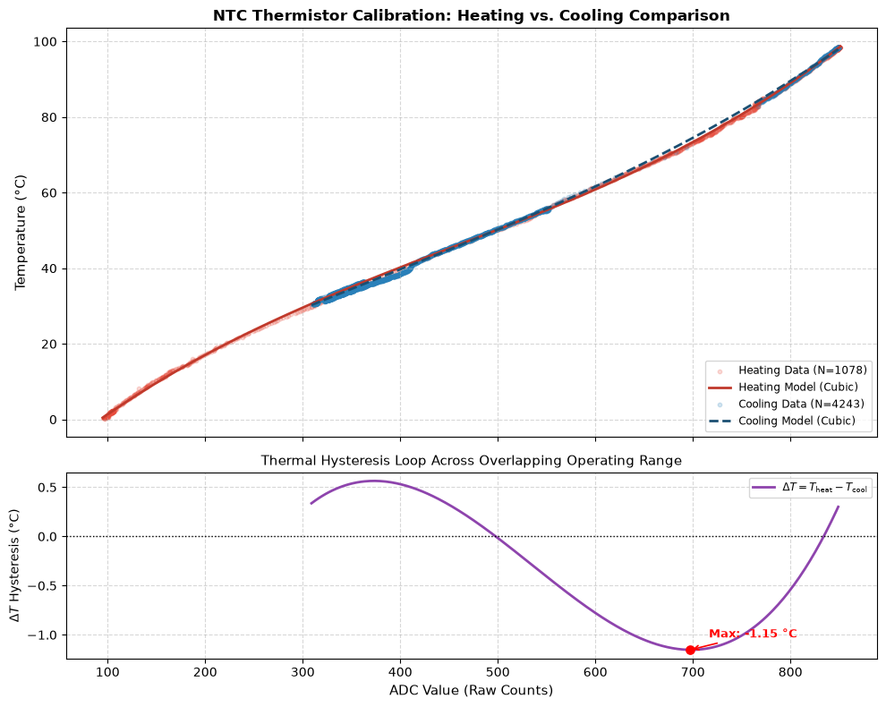 | 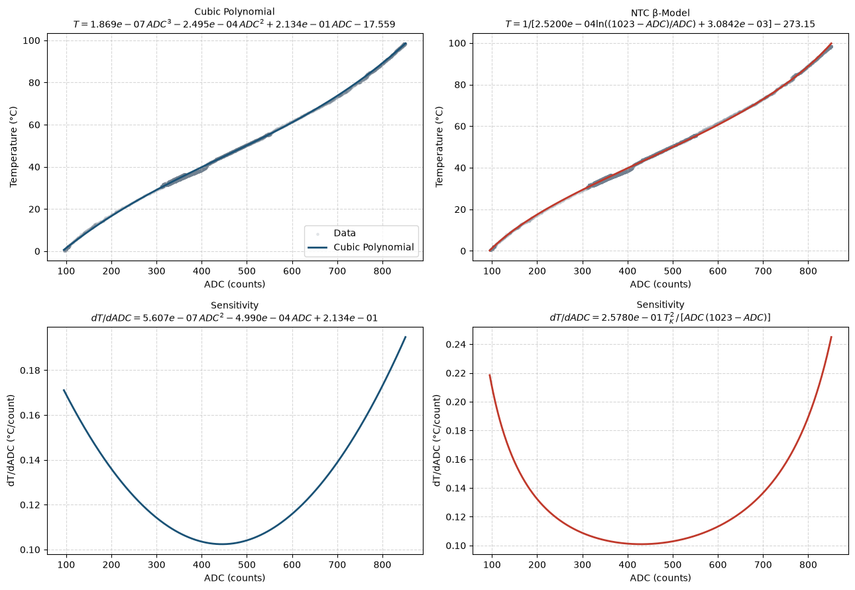
Figure 3. Left: heating vs. cooling fits and the gap ΔT. Right: fitted curves and sensitivity of both models.
For the response time, we fitted $T(t)=T_{f}+(T_{i}-T_{f}) e^{-(t-t_{0})/τ}$ to 3 clean periods together. The thermistor has τ = 3.5 ± 0.3 s when heating and 7.7 ± 2.2 s when cooling (the β-model gives 3.3 s and 8.6 s). Cooling is slower and less certain: one period was much slower, and the ice bath warmed by about 2 °C in period 2.

4. Error & Uncertainty Analysis

4.1 Sources of Error
- Measurement precision: the DS18B20 is ±0.5 °C (we assume about ±1 °C in practice).
- ADC resolution: one count is worth 0.10 to 0.25 °C, coarsest at both ends of the range.
- Thermal lag: the NTC and the reference probe have different time constants, so one trails the other when the temperature changes.
- Self-heating: P = I²R is at most about 1.9 mW with a 5 V supply. We did not measure it.
Datasheet comparison: [Insert the datasheet β (B-value) here.] Our fitted β = 3965.3 K.

4.2 Uncertainty Calculations
The regression standard error is 0.54 °C for the cubic and 0.60 °C for the β-model. The percentage error against the datasheet β is [Insert: |β_{fit} − β_{datasheet}|/β_{datasheet} × 100.] The combined standard uncertainty adds three independent sources:
$$u_{T}=\sqrt{u_{ref}^{2}+(dT/dADC)^{2} u_{ADC}^{2}+g^{T}C g}$$
Here $u_{ref}=0.5$ °C, $u_{ADC}=0.5$ count, g = $∂T/∂(parameters)$ and C is the parameter covariance matrix. The reference dominates (the ADC term is at most 0.12 °C and the fit term at most 0.04 °C). So the largest u_{T} is ±0.51 °C for the cubic and ±0.52 °C for the β-model, or about ±1.0 °C at 95 %. This is close to the measured RMSE and agrees with the ±1.06 °C prediction band.

5. Discussion & Conclusion

Both models calibrate the thermistor to within the ±1 °C uncertainty of the DS18B20, and their RMSE differ by only 0.06 °C. The cubic is slightly better inside the measured range (0–98 °C). The β-model is almost as good with half the parameters, works well outside the range, and gives a real physical constant. The relative sensitivity $α=-β/T^{2}$ is about −5.3 %/K at 0 °C and −2.9 %/K at 98 °C. The heating/cooling gap is below the reference uncertainty, so one calibration works for both directions. The final equations are:
$$T=1.869×{10}^{-7}a^{3}-2.495×{10}^{-4}a^{2}+0.2134a-17.559 °C (±1.06 °C, 95\%)$$
$$T=1/[2.520×{10}^{-4}ln((1023-a)/a)+3.0842×{10}^{-3}]-273.15 °C (β=3965.3 K)$$
Limits. The DS18B20 is only accurate to ±0.5 °C, lag between the sensors adds error during fast changes, and only three runs were usable, so do not use the cubic outside 0–98 °C. We recommend the β-model as the main calibration, and the cubic only when you need the lowest error inside this range.

Prelab Activities

1. Nominal resistance. It is the resistance of the thermistor at the reference temperature of 25 °C (R₂₅), given in the datasheet with a tolerance. Here it is 3.3 kΩ.
2. Interfacing methods.
• Voltage divider: simplest and cheapest, and an ADC reads it directly. The output is not linear, and the divider current causes self-heating.
• Wheatstone bridge: cancels the offset and is very sensitive to small changes. It needs more resistors and an amplifier.
• Constant-current source: the voltage is proportional to the resistance, so the divider non-linearity is gone. It needs a current source and still self-heats.
• Op-amp or linearising network: gives gain or a straighter response. It needs more parts and also amplifies noise.
• RC timing or digital converter: gives a digital output with good accuracy. It needs timing code or a special chip.
3. Terms. Accuracy is how close the measured temperature is to the true one (±0.5 °C from our reference). Precision is how well repeated readings agree (limited here by the ADC to 0.10–0.25 °C per count). Span is the temperature range measured (0 to 98 °C). Dynamic range is the largest to the smallest output measured (ADC counts 97 to 850, about 9:1). Sensitivity is the output change per degree, dADC/dT (4–10 counts/°C here), or $α=-β/T^{2}$ (about −4.5 %/K at 25 °C).
4. PSPICE simulation. We did not run PSPICE. We did the same calculation numerically (item 7).
5. Two configurations. In the divider, the fixed resistor R_{f} and the NTC can swap places: (A) NTC to GND with the output across the NTC, and (B) NTC to V_{cc} with the output across R_{f}.
6. Assumed values. R₂₅ = 3.3 kΩ for the NTC, R_{f} = 3.3 kΩ, V_{cc} = 5 V and β = 3965 K (our fitted value, as the prelab gives none).
7. Numerical simulation, 0 to 100 °C.
Table 2. Simulated output voltages and sensitivity of the two configurations.
T (°C) | R_{NTC} (kΩ) | V_{A} (V) | V_{B} (V) | |dV/dT| (mV/K)
0 | 11.1 | 3.858 | 1.142 | 46.9
25 | 3.30 | 2.500 | 2.500 | 55.8
50 | 1.18 | 1.316 | 3.684 | 36.8
75 | 0.49 | 0.645 | 4.355 | 18.4
100 | 0.23 | 0.323 | 4.677 | 8.6
The two outputs always add up to V_{cc} (V_{A} + V_{B} = V_{cc}), so |dV/dT| is exactly the same for A and B. It is highest near 18.5 °C (57 mV/K, about 11.6 counts/K) and falls to 8.6 mV/K at 100 °C. So neither configuration is more sensitive. They only differ in direction: A falls and B rises as the temperature rises.
8. Choice for further studies. Because both are equally sensitive, either can be used. We used the circuit in Section 2.1.

